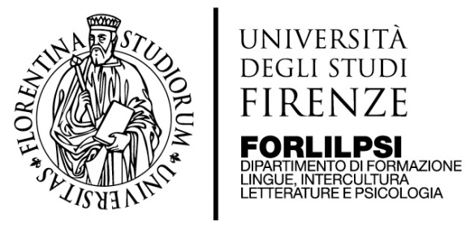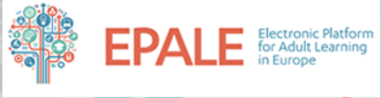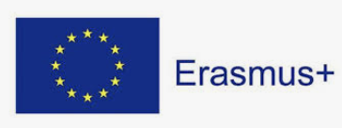

Multiplier Event, Firenze 12/03/2020
European Manifesto for Inclusive Learning. Tackling challenges of future adult education in Europe
Manifesto Europeo della formazione accogliente. Le sfide dell’educazione del futuro in Europa

Preliminary Agenda

H. 9.30 Registration at Aula Magna, Rettorato dell’Università di Firenze, Piazza San Marco 4
H. 10.30 Institutional Welcome
H. 10.45 Presentation of the objectives and organization of the Conference
H.11.00-11.15 Presentation of Erasmus 2021-27
H.11.15-12.00 Keynote speech on Human Mobility and Education
H. 12.00-12.30 Brunch and networking
H.12.30- 14.30 Three Working groups: culture and language; labour and training; community (each group has a facilitator from the partnership and discussants of experiences and theoretical approaches)
H.14.30-15.00 Coffee break and networking
H.15.00-16.00 Restitution of results in working groups to an expert panel (decision-makers)

Working language will be English

Call for paper and experiences

Please also see the attached guide (annex I) for collection of practices
Background of the call

International migration and human mobility are a growing phenomenon, both in scope and in complexity, affecting all countries, and communities, around the world. Cause-effects relations are diverse and can be found in globalization in broad terms. In literature, they can be traced to international patterns of demand for and supply of labour, the relative cheapness of international transport, the advent of systems of electronic communication and the emergence of transnational family networks. Social, economic and demographic inequalities, in terms of employment opportunities, resources, security, education or human rights are also key “push and pull” factor that make people, within the different regions of the south and north of the world, plan their life and professional project globally, rather than locally. According to the UN Department of Social and Economic Affairs In 2019, out of 7 billions world population (UN 2009) international migrants are estimated to 272 million, with an increase of 51 million since 2010. The number of international migrants is growing faster than the total population, making their share of the world’s population every day more relevant and representing one of the major challenges of our time for transnational organizations, national governments and local communities. Today international migrants comprise 3.5 per cent of the global population, compared to 2.8 per cent in the year 2000. Many urgent questions emerge? Is it still useful to distinguish between voluntary and non-voluntary migrations? The number of refugees and asylum seekers increased by about 13 million between 2010 and 2017, accounting for close to a quarter of the increase in the number of international migrants. Refugees and asylum seekers increased at an annual average rate of over 8 per cent between 2010 and 2017, while other migrants increased at an annual rate of under 2 per cent between 2010 and 2019. Still, this is a global challenge, not only an issue of the “developed” North of the planet. As of 2017 in fact, over 83 per cent of refugees and asylum seekers lived in the South, while Europe hosts a little more than 30% of the total migrant population.

According to EUROSTAT, 22.3 million people (4.4 %) of the 512.4 million people living in the EU on 1 January 2018 were non-EU citizens and 2.4 million immigrants entered the EU from non-EU countries in 2017. Migrants play an important role in the EU labour markets and economies and the most successful integration happens at the workplace: migrants’ participation gain importance in the various EU host countries, even still encountering challenging disparities. In 2018, the EU employment rate of persons aged 20-64 years ranged from 64.5 % among persons born outside the EU, through 73.9 % among the native-born population, to 76.5 % for persons born in another EU Member State. A gender gap, with lower employment rates for women than for men, could be observed by EUROSTAT in nearly all of the EU Member States while employment rates were highest among people with a tertiary level of education and lowest among those with at most a lower secondary level of education, this pattern being similar for autochthone, EU nationals and migrants.

In Italy, according to ISTAT there are 5.1 millions immigrants representing 8.5% of the total population while, according to UNHCR, we passed from more than 181thousands asylum seekers in 2016 to slightly over 11thousands in 2019. Such abrupt reduction is due to intergovernmental wicked agreements, rather than an effective change in human mobility. A key piece of information for Italy is not often disseminated by media: in 2017 according to IDOS (Caritas, UNAR and Waldensian Evangelical Church) 285thousands
s left Italy for a better future, a third with a tertiary education and more than a half from the North of the country, while only 262.770 non EU nationals entered Italy in the same year. In other words, more Italians emigrate, than migrants from abroad arrive.

Numbers are key to understand the human mobility phenomenon and prevent manipulation of information, but how do we transform them into real-life stories, accounting for people’s dreams and projects in a global market? How do we tell the story of thousands of organizations and activist that are reorganizing services in order to provide to basic and development needs of migrants? Are innovative and transformative approaches to education and training, especially in non-formal and informal learning setting, an opportunity for all, migrant and autochthone population, to rethink the social pact of the future, well beyond cultural, national and ethnic boundaries of the past?

In the framework of the Erasmus Project European Manifesto for Inclusive Learning, the University of Firenze has organized a participatory event where we intend to share lessons learnt and a renewed vision for the future of education in a globalized world, starting from the “Manifesto for Inclusive Learning”, a declaration issued in September 2017 in La Spezia, in the framework of an Erasmus-EPALE national seminar with more than 150 educators, researchers and activists from all parts of Italy.

In its words, the Manifesto of Inclusive Learning puts each citizen with his/her life experience and cultural heritage at the centre of the continuous education process and recognizes the innovation of education and training approaches as an opportunity to promote social change and build a Europe for all from the grassroots. Education and training, be it formal, non-formal or informal, are therefore understood as an arena for a dynamic relationship that transforms and connects teachers and learners, in every place and time of life.

In order to learn from each other and overcome the well-known fragmentation of experiences and learning in our time, this seminar offers a participatory open space for mutual learning, community making and networking where we especially welcome narration of experiences, research papers, policy papers, and presentations related to a broad range of questions and topics associated with adult education and human mobility. What are the contemporary theories, theoretical paradigms, and/or educational practices relevant to transforming the contemporary education system in order to make it truly respondent to the diverse learning needs of the globalized citizen? What are the pedagogical best practices associated with the education and training of migrant adults or of the local community on human mobility issues? What is the role of advocacy in mainstreaming education and training as a trending issue in immigration policies and in promoting a sound innovative and systematic proposal, adequate to respond to the needs of a culturally intelligent globalized citizen?

Together with our international partners from Finland, Germany, Greece, the Netherlands, Poland and UK, we have identified three main topics of reflection:

- Culture and Language (cultural heritage, cultural intelligence, cultural rights, arts-based education, second language learning, multilingualism, intercultural mediation, interreligious dialogue, just to mention a few)

- Labour and Training (labour market, vocational training, higher education, entrepreneurship, skills recognition, just to mention a few)

- Community Engagement (public/private alliances, networking, grassroots practices, advocacy, storytelling, identity and diversity, solidarity and mutuality, just to mention a few)

Each proposal should be comprised in one of the three topics, in order to select and participate in one of the three groups work with the same date during the event.
Proceedings of the event will be published on EPALE Journal for Adult Learning and Continuous Education and made available open access to participants and the learning community.

Abstracts in English or Italian should be sent to:

edulaber@forlilpsi.unifi.it and gilda.esposito@unifi.it
within Monday 3rd of March 2020.
Participation to the seminar is free and lunch and coffee break are offered by UNIFI thanks to Erasmus funds.

In collaboration with:

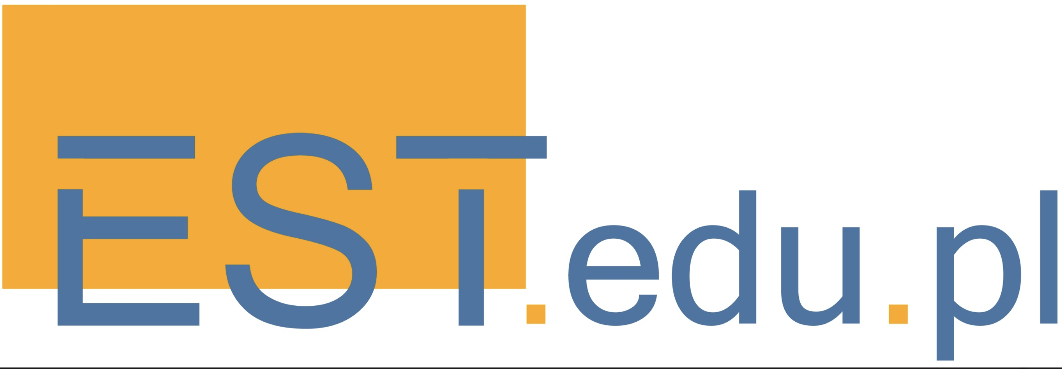

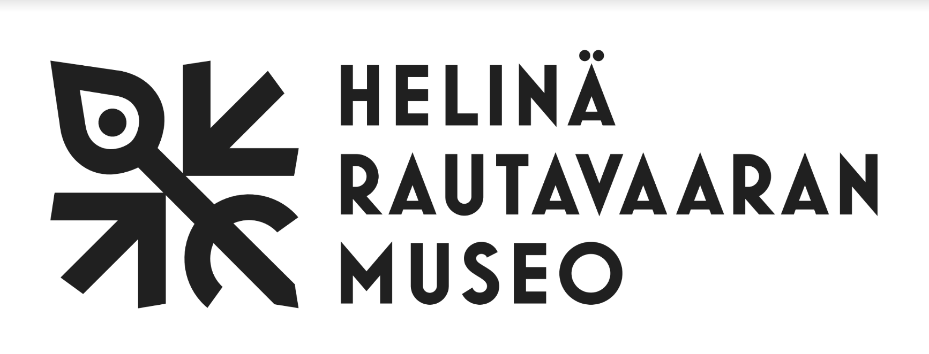

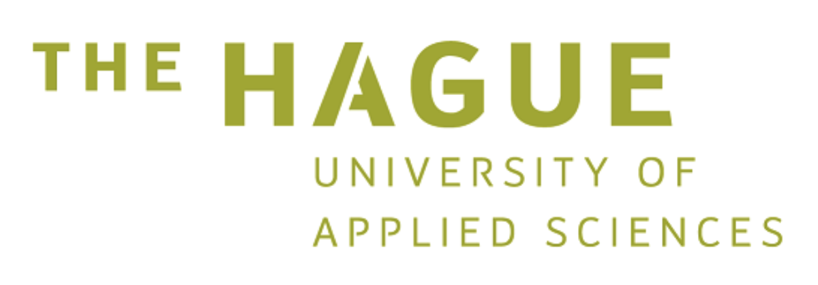

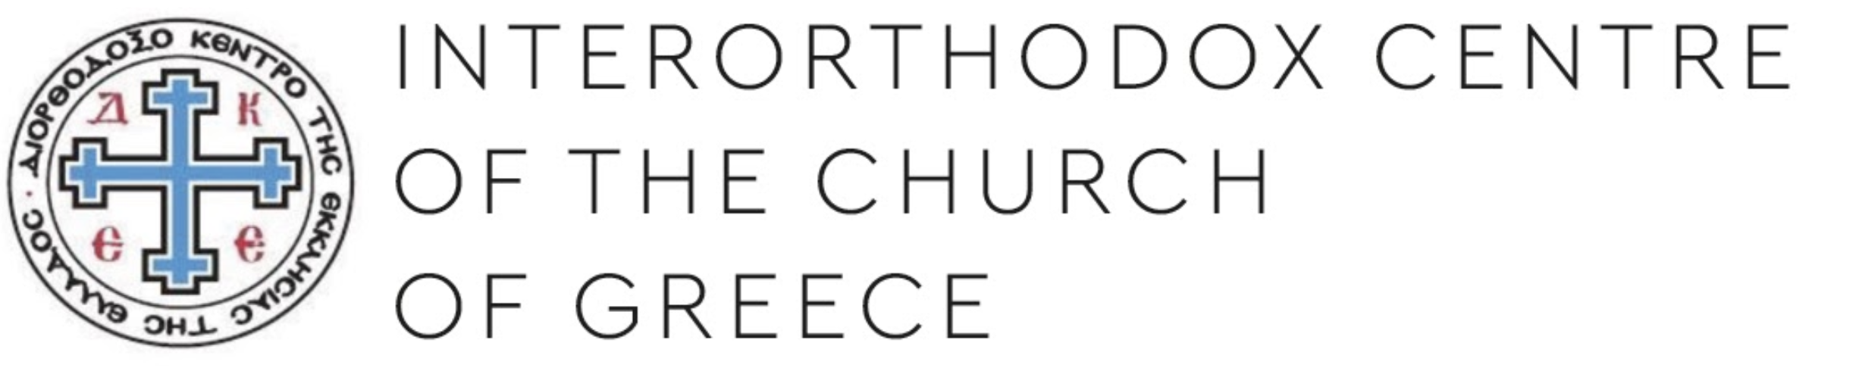

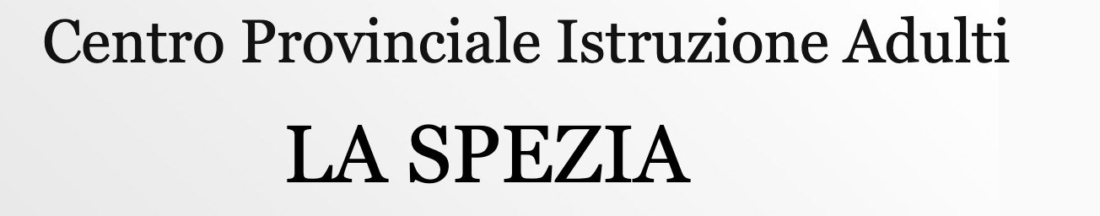

Annex I

European Manifesto for Inclusive Learning
Description of successful practices of inclusion of migrants through education and training

According to the Manifesto for Inclusive Learning launched by EPALE and the University of Firenze in La Spezia last September 2017, each citizen with his/her cultural heritage should be at the center of continuous education. It recognizes the diversity and innovation of education and training approaches as an opportunity to promote social change and build a Europe for all from the grassroots.

The objective of this grid is to support and guide practitioners in describing existing practices on migrants’ and asylum seekers/refugees’ integration in hosting societies trough education and training. Authors can freely choose to use another format for their contributions.

The practices will be presented at the multiplier event in Firenze on 12/03/2020 and published on a dedicated volume of the EPALE Journal on Adult Learning and Continuous Education.
Selected practices should provide evidences/demonstrate the value of applying an education and training-based strategy in inclusive policies and practices for a welcoming Europe, that transform and improve not only migrants’ lives, but the society at large.

In a transition phase between a society that no longer exists and one that we are still designing, the following ten general principles apply:

1. Centrality of education and training, be it formal or non-formal, understood as a relationship that transforms and connects those who teach and those who learn, in every place and time of life.
2. Hosting, understood as the recognition of the common humanity of the other person and his/her needs and aspirations, without discrimination
3. Solidarity, intended as an enhancement of sharing, reciprocity and mutual self-help
4. Protection of the weakest, understood as the ability to always look at the world from the point of view of the most fragile, offer them first protection and then paths to autonomy.
5. Confidence in a shared future, intended as the conscious choice to include migrant people, starting from young people and women, first or second generation, in the design of an inclusive society, as the result of the meeting and the metissage between different stories, cultures and interpretations of the world
6. Accountability of the Institutions and the Third Sector, seen as an instrument of transparency and security for all citizens and their associations.
7. Networking to strengthen collaboration and stimulate creative synergy and social innovation
8. Evidence-based approach, understood as continuous attention to the scientific analysis of change, based on quantitative, qualitative and mixed tools and methods, to overcome perceptions, stereotypes and information that are often distorted and manipulated.
9. Centrality of a narrative approach, understood as a research method and a tool for respectful dialogue on the “stories” that make "History"
10. Curiosity and respect for all the diversity of which everyone is a bearer against the culture of hate, xenophobia and any possible expression of intolerance

PART I CONTACT DATA
Name of the organization implementing the action
Website/Social Network
Name of Contact Person and Role within the project/teaching programme
E-mail (if they agree to be contacted for further information)
Address (Town and Country)
Are you part of any national, European or International thematic network? Please specify
PART II INFO ON THE INCLUSIVE EDUCATION & TRAINING PRACTICE
Number of teachers/educators/trainers/volunteers or other operators involved
Does it involve:
Refugees
Migrants in general
Operators and educators working with migrants/refugees
Local Communities
Other (please specify)
Characteristics of participants (nationality, age, any other interesting characteristic)
Average number of learners
Sex disaggregation of participants (if available)
Concise description of the learning experience | .
Have you established a satisfactory collaboration with the public service network, including Municipalities, schools, vocational centres and Universities?
Have you established a satisfactory collaboration with other civil society actors/activists?
Have you established a satisfactory collaboration with migrant communities representatives, if any?
Do you collaborate local social and educational services?
On line platform or app for e-mobile learning, if available
Please describe the strengths of the approach/practice
Please describe the weaknesses of the approach/practice
Indicators of success
Story telling (anecdotes) worth to be reported
Project Homepage/Social Network if any
Training kits or tools available online or offline
How is the activity financed (public, private funds, project based)
Pictures, videos, any media available

Please choose on which of the following principles you would like to share your experience.

Principle | How is it it met?
1. Centrality of education and training, be it formal and non-formal, understood as a relationship that transforms and connects those who teach and those who learn, in every place and time of life.

2. Hosting, understood as the recognition of the common humanity of the other person and his/her needs and aspirations, without discrimination

3. Solidarity, intended as an enhancement of sharing, reciprocity and mutual self-help

4. Protection of the weakest, understood as the ability to look at the world always from the point of view of the most fragile, offer them protection first and paths of autonomy than.

5. Confidence in a shared future, intended as the conscious choice to include migrant people, starting from young people and women, first or second generation, in the design of an inclusive society, as the result of the meeting and the metissage between different stories, cultures and interpretations of the world

6. Accountability of the Institutions and the Third Sector, seen as an instrument of transparency and security for all citizens and their associations.

7. Networking to strengthen collaboration and stimulate creative synergy and social innovation

8. Evidence-based approach, understood as the continuous tension towards the scientific analysis of change, based on quantitative, qualitative and mixed tools and methods, to overcome perceptions, stereotypes and information that are often distorted and manipulated.

9. Centrality of narrative approach, understood as a research method and a tool for respectful dialogue on the “stories” that make "History"

10. Curiosity and respect for all the diversity of which everyone is a bearer against the culture of hate, xenophobia and any possible expression of intolerance

Please add anything you might see fit

Name of the author

Date and Place

Annex II
Manifesto for inclusive learning (English version translated from Italian)

“To know in order to welcome; welcome to include”

“Throughout history, people have migrated from one place to another. People try to reach European shores for different reasons and through different channels. They look for legal pathways, but they also risk their lives, to escape from political oppression, war and poverty, as well as to find family reunification, entrepreneurship, knowledge and education. Every person's migration tells its own story.”
European Agenda on Migration

The Manifesto of Inclusive Learning puts each citizen with his/her cultural heritage at the centre of continuous education and recognizes the diversity of education and training approaches as an opportunity to promote social change and build a Europe for all from the grassroots.

The Manifesto was co-created from the experiences of over 150 participants at the EPALE National Seminar "La Formazione Accogliente" (Inclusive Education) held in La Spezia on 14-16 September 2017.
Through the Manifesto the signatories have designed a shared horizon to their educational agency, with common objectives and language.

The principles of the Manifesto

In a transition phase between a society that no longer exists and one that we are still designing, the following ten general principles apply:

1. Centrality of education and training, be it formal or non-formal, understood as a relationship that transforms and connects those who teach and those who learn, in every place and time of life.
2. Hosting, understood as the recognition of the common humanity of the other person and his/her needs and aspirations, without discrimination
3. Solidarity, intended as an enhancement of sharing, reciprocity and mutual self-help
4. Protection of the weakest, understood as the ability to always look at the world from the point of view of the most fragile, offer them first protection and then paths to autonomy.
5. Confidence in a shared future, intended as the conscious choice to include migrant people, starting from young people and women, first or second generation, in the design of an inclusive society, as the result of the meeting and the metissage between different stories, cultures and interpretations of the world
6. Accountability of the Institutions and the Third Sector, seen as an instrument of transparency and security for all citizens and their associations.
7. Networking to strengthen collaboration and stimulate creative synergy and social innovation
8. Evidence-based approach, understood as continuous attention to the scientific analysis of change, based on quantitative, qualitative and mixed tools and methods, to overcome perceptions, stereotypes and information that are often distorted and manipulated.
9. Centrality of a narrative approach, understood as a research method and a tool for respectful dialogue on the “stories” that make "History"
10. Curiosity and respect for all the diversity of which everyone is a bearer against the culture of hate, xenophobia and any possible expression of intolerance

Who is the Manifesto addressed to?

The manifesto puts the focus on three main stakeholders who are recipients of the actions that are developed in the CPIA, SPRAR, CAS and all the other areas of response to migrants. The three groups interact and for each one the following necessary actions are identified below:

Applicants for international protection (asylum seekers) and migrants
Thanks to an adequate and personalized training process, they consolidate knowledge, skills and attitudes useful for realizing their life project through:
• Recognition of formal, non-formal and informal skills and support in the construction of a personal and professional project
• Literacy in the language of the host country
• Vocational training for the labour market
• Guidance (ex. job grants and traineeships)
• Access to University and tertiary education
• Civic education, on the rule of law and guidance to compliance with the rules of the host country
• Accompaniment to know and understand the characteristics and culture of the host territory
• Training on career management skills, in particular critical thinking, effective and transformative communication, creativity, team working, just to name a few
• Recognition of one's own cultural heritage, including the freedom to profess one's religion while respecting all the others
The signatories of the Manifesto, therefore, propose putting in place an integrated model of training and guidance to sustain territorial and labour market knowledge.

Operators of the reception chain
Each operator must receive appropriate training and develop skills, knowledge and attitudes in line with national and European policies in order to:
• Listen, guide, mediate and support migrants with methods and techniques appropriate to them and their specific needs (only as an example: unaccompanied minors, women survivors of violence or adults with post-traumatic stress)
• Manage the various stages of the reception chain, according to their skills and knowledge (consistent with needs in the legal, psychological, pedagogical, health sectors etc.)
• Understand and collaborate with the entire network of public and private institutions at a local, national and international level
• Enjoy continuous training, pre-service and at the workplace
• Propose, plan and implement innovation of services and projects, based on own experience and continuous evaluation, be it internal self-assessment and impact evaluation, based on shared and validated indicators
• Collaborate with teachers of the Provincial Centres of Adult Education (CPIA), which are public schools and service networks intended as point of departure and arrival of each asylum seekers’ training process
• Design and nurture creative opportunities for information, intercultural dialogue and activation for the common good among local autochthonous and migrant communities
• Communicate correctly with migrant communities taking into account the intercultural dimension
• Get to know basic elements of the history and cultural heritage of the migrants’ countries of origin
• Communicate and disseminate their work, including through ICT, in order to make information and initiatives accessible to all.

The signatories of the Manifesto therefore propose recognizing a new professional figure, the so called "operator of migrants' reception chain", trained to act as indicated, at the levels 5 to 8 of the European Qualification Framework EQF

Local educating communities
They are the protagonists of change and represent the educating community that welcomes and includes migrants. They should be activated in collaboration with the Institutions, the service network and the Third Sector and contribute to building a territory that is fit for everyone, with a social and productive fabric that generates inclusion, labour and well-being.
Therefore it is important to stimulate the following non-formal and informal education processes:
• Create opportunities for sharing and participation that foster mutual knowledge, dialogue and overcoming

