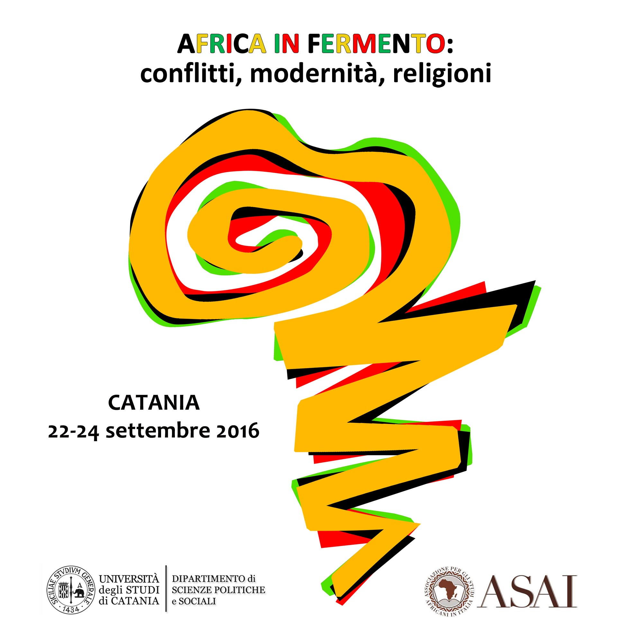

IV ASAI Conference

Africa in fermento. Conflitti, modernità, religioni
Ebullient Africa: Conflict, Modernity, Religion

Catania 22 - 24 September 2016

TITLE:

ABSTRACT:
350 words

PROPOSER’S ACADEMIC PROFILE:
300 characters (excl. spaces)

